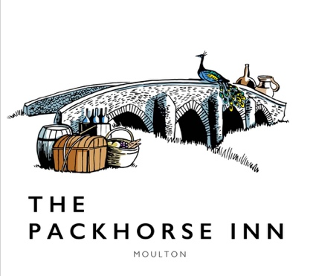

OYSTER MENU
3 for £12

YOUR CHOICE OF GARNISH:

Champagne Granita

Dill, Granny Smith Apple & Fermented Cucumber

Pickled new season Plums with Butterfly Sorrel

WINE PAIRING

Saffron Grange Classic Cuvée, Essex England
Glass £10 | Bottle £57.50

Please let a team member know of any allergies or dietary requirements

