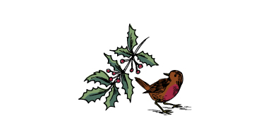

FESTIVE Menu

Mon - Thurs
Lunch £30 Dinner £34
Fri - Sat
Lunch £35 Dinner £37
Sunday £37

STARTERS
Roasted Cauliflower Soup with Caper & Walnut dressing GF DF VG

Citrus-cured Salmon, Horseradish cream, Cucumber, Dill & Citrus salad GF

Salt Baked Beetroot & Kohlrabi salad with Ricotta cheese & Hazelnut Dukkha GF (vegan on request)

mains

Roast Norfolk Turkey, Pigs in Blankets, Sausage stuffing, roast Potatoes, Brussel Sprouts,
Carrots & Cranberry
Sea Bream, split roasted sauce, Mussels, golden Sultanas, roasted Parsnip purée & crispy Parsnips GF
Salt baked Celeriac Steak, Suffolk blue cheese, candied Walnuts, baby Leeks & chives GF
(vegan on request)

DESSERTS
East Anglian Cheese Board, Grapes, Quince & Crackers

Individual Chocolate Tart, salted Caramel ice cream, Chocolate crunch

Christmas Pudding, Brandy sauce, Mincemeat ice cream GF
V Vegetarian VG Vegan GF Gluten Free
Please let a team member know of any allergies or dietary requests
Share your visit on social using #chestnutchatter to be in with a chance of winning a night’s stay at one of our Chestnut inns www.chestnutgroup.co.uk

